**МІНІСТЕРСТВО ОСВІТИ ТА НАУКИ**

**НАЦІОНАЛЬНИЙ УНІВЕРСИТЕТ ЛЬВІВСЬКА ПОЛІТЕХНІКА**



**АВТОМАТИЗОВАНЕ ПРОЕКТУВАННЯ**

**КОМП’ЮТЕРНИХ СИСТЕМ**

Task4 Create doxygen documentation

Виконав :

Студент групи КІ-401

Онисько М.М.

Прийняв:

Федак П.Р

**2024**

**Завдання:**

1. Розробити Doxygen документацію
2. Створити CI файл для автоматизованого встановлення та генерації документації
3. Оновити Readme.md
4. Додати тег про нову версію
5. Злити створену гілку до develop

**Теоретичні відомості:**

Doxygen — кросплатформна система документування початкового коду програм, яка підтримує C++, Сі, Objective-C, Python, Java, IDL, PHP, Perl, C#, Фортран, VHDL і, частково, D.

Приклад програми мовою C++

|  |
| --- |
| **class** **Time** {    **public**:    */\*\**  *\* Constructor that sets the time to a given value.*  *\**  *\* @param timemillis Number of milliseconds*  *\* passed since Jan 1, 1970.*  *\*/*  Time (int timemillis) {  *// the code*  }    */\*\**  *\* Get the current time.*  *\**  *\* @return A time object set to the current time.*  *\*/*  **static** Time now () {  *// the code*  }  }; |

Doxygen має вбудовану підтримку генерації документації в форматі HTML, LaTeX, man, RTF і XML. Також результати його роботи можуть бути легко конвертовані в CHM, PostScript, PDF.

Для HTML-представлення документації, що розміщується на web-серверах, існує зручний спосіб організації пошуку (за допомогою створюваного Doxygen'ом PHP-модуля) і посилань на зовнішню документацію.

Doxygen використовується в багатьох проектах, в тому числі KDE, Pidgin, Torque Game Engine, AbiWord, Mozilla, FOX toolkit, Crystal Space, Drupal. Є вбудована підтримка в KDevelop.

Doxygen — консольна програма в стилі класичної Unix. Вона працює подібно компілятору, аналізуючи вихідні тексти і створюючи документацію. Додаткові параметри для створення документації можуть читатись із конфігураційного файлу, що має простий текстовий формат.

Для спрощення маніпуляцій з конфігураційним файлом (який містить досить багато налаштувань), існує кілька програм з графічним інтерфейсом: програма doxywizard (реалізована з використанням Qt-3) поставляється разом з Doxygen; програма Doxygate заснована на Qt версії 4. Пізніше doxywizard був переписаний на Qt-4 і проект Doxygate був закритий.

Doxygen генерує документацію на основі набору вихідних текстів і також може бути налаштований для вилучення структури програми з недокументованих вихідних текстів. Можливе складання графів залежностей програмних об'єктів, діаграм класів та вихідних кодів з гіперпосиланнями.

**Виконання**

**Код скрипту для HW частини**

|  |
| --- |
| #include <Arduino.h>  #include <ArduinoJson.h>  const int BOARD_SIZE = 3;  char board[BOARD_SIZE][BOARD_SIZE];  char currentPlayer = 'X';  bool gameOver = false;  int gameMode = 0;  /**  * @brief Initializes the TicTacToe board and resets game variables.  * Sets all board positions to empty (' ') and sets the current player to 'X'.  */  void initializeBoard() {  for (int i = 0; i < BOARD_SIZE; i++) {  for (int j = 0; j < BOARD_SIZE; j++) {  board[i][j] = ' ';  }  }  currentPlayer = 'X';  gameOver = false;  }  /**  * @brief Sends a JSON message over Serial.  *  * @param type The type of message (e.g., "info", "error", "win_status").  * @param message The message content.  */  void sendJsonMessage(const char* type, const char* message) {  StaticJsonDocument<200> doc;  doc["type"] = type;  doc["message"] = message;  serializeJson(doc, Serial);  Serial.println();  }  /**  * @brief Sends the current state of the board over Serial as a JSON message.  */  void sendBoardState() {  StaticJsonDocument<300> doc;  doc["type"] = "board";  JsonArray boardArray = doc.createNestedArray("board");  for (int i = 0; i < BOARD_SIZE; i++) {  JsonArray row = boardArray.createNestedArray();  for (int j = 0; j < BOARD_SIZE; j++) {  row.add(String(board[i][j]));  }  }  serializeJson(doc, Serial);  Serial.println();  }  /**  * @brief Checks if the current player has won the game.  *  * @return true if the current player has a winning combination, false otherwise.  */  bool checkWin() {  for (int i = 0; i < BOARD_SIZE; i++) {  if (board[i][0] == currentPlayer && board[i][1] == currentPlayer && board[i][2] == currentPlayer) return true;  if (board[0][i] == currentPlayer && board[1][i] == currentPlayer && board[2][i] == currentPlayer) return true;  }  if (board[0][0] == currentPlayer && board[1][1] == currentPlayer && board[2][2] == currentPlayer) return true;  if (board[0][2] == currentPlayer && board[1][1] == currentPlayer && board[2][0] == currentPlayer) return true;  return false;  }  /**  * @brief Checks if the game has ended in a draw.  *  * @return true if the board is full and there is no winner, false otherwise.  */  bool checkDraw() {  for (int i = 0; i < BOARD_SIZE; i++) {  for (int j = 0; j < BOARD_SIZE; j++) {  if (board[i][j] == ' ') return false;  }  }  return true;  }  /**  * @brief Performs a random move for the AI.  * Places the current player's symbol at a random empty position on the board.  */  void aiMoveRandom() {  while (true) {  int row = random(0, BOARD_SIZE);  int col = random(0, BOARD_SIZE);  if (board[row][col] == ' ') {  board[row][col] = currentPlayer;  break; // Exit the loop after a valid move  }  }  }  /**  * @brief Handles an AI vs AI game mode, making random moves until the game is over.  * Alternates moves between two AI players until a win or draw condition is met.  */  void handleAiVsAi() {  while (!gameOver) {  if (checkDraw()) {  sendJsonMessage("win_status", "It's a draw!");  gameOver = true;  return;  }  aiMoveRandom(); // AI makes a random move  if (checkWin()) {  String message = "Player " + String(currentPlayer) + " wins!";  sendBoardState();  sendJsonMessage("win_status", message.c_str());  gameOver = true;  return;  }  currentPlayer = (currentPlayer == 'X') ? 'O' : 'X'; // Switch players  sendBoardState(); // Send the board state after each move  }  }  /**  * @brief Makes a move for the current player at the specified board position.  *  * @param row The row index (0-2).  * @param col The column index (0-2).  * @return true if the move is valid and successful, false otherwise.  */  bool makeMove(int row, int col) {  if (row >= 0 && row < BOARD_SIZE && col >= 0 && col < BOARD_SIZE && board[row][col] == ' ' && !gameOver) {  board[row][col] = currentPlayer;  if (checkWin()) {  String message = "Player " + String(currentPlayer) + " wins!";  sendJsonMessage("win_status", message.c_str());  gameOver = true;  } else if (checkDraw()) {  sendJsonMessage("win_status", "It's a draw!");  gameOver = true;  } else {  currentPlayer = (currentPlayer == 'X') ? 'O' : 'X';  }  return true;  }  return false;  }  /**  * @brief Initializes the game and sends a startup message.  * Sets up Serial communication and initializes the board.  */  void setup() {  Serial.begin(9600);  initializeBoard();  sendJsonMessage("info", "TicTacToe Game Started");  }  /**  * @brief Main game loop, reads Serial input and processes commands.  * Processes moves, resets, and mode changes based on JSON commands from Serial input.  */  void loop() {  if (Serial.available() > 0) {  StaticJsonDocument<200> doc;  String input = Serial.readStringUntil('\n');  DeserializationError error = deserializeJson(doc, input);  if (!error) {  const char* command = doc["command"];  if (strcmp(command, "MOVE") == 0) {  int row = doc["row"];  int col = doc["col"];  if (makeMove(row, col)) {  sendBoardState();  } else {  sendJsonMessage("error", "Invalid move.");  }  } else if (strcmp(command, "RESET") == 0) {  initializeBoard();  sendJsonMessage("game_status", "Game reset.");  sendBoardState();  } else if (strcmp(command, "MODE") == 0) {  gameMode = doc["mode"];  String message = "Game mode set to " + String(gameMode);  sendJsonMessage("game_mode", message.c_str());  initializeBoard();  sendJsonMessage("game_status", "Game reset.");  sendBoardState();  }  // AI move logic if applicable  if (gameMode == 1 && !gameOver && currentPlayer == 'O') {  aiMoveRandom(); // Make a random move for the AI  if (checkWin()) {  String message = "Player " + String(currentPlayer) + " wins!";  sendJsonMessage("win_status", message.c_str());  gameOver = true;  } else if (checkDraw()) {  sendJsonMessage("win_status", "It's a draw!");  gameOver = true;  }  currentPlayer = 'X'; // Switch back to Player X  sendBoardState();  } else if (gameMode == 2 && !gameOver) {  handleAiVsAi(); // Handle AI vs AI  }  }  }  } |

**Код клієнтської частини**

|  |
| --- |
| import threading  import serial  import serial.tools.list_ports  import json  import tkinter as tk  from tkinter import ttk, scrolledtext  from tkinter import messagebox  class UARTCommunication:  """  Class to handle UART communication, including opening ports, sending and receiving messages.  """  def __init__(self):  """  Initializes the UARTCommunication instance.  """  self.ser = None  def list_ports(self):  """  Lists all available serial ports.  @return A list of available serial port names.  """  return [port.device for port in serial.tools.list_ports.comports()]  def open_port(self, port, baud_rate=9600):  """  Opens a specified serial port with a given baud rate.  @param port The serial port to open.  @param baud_rate The baud rate for the port (default is 9600).  @return A message indicating whether the port was opened successfully or an error occurred.  """  try:  self.ser = serial.Serial(port, baud_rate, timeout=1)  return f"Connected to {port}"  except Exception as e:  self.ser = None  return f"Error: {e}"  def send_message(self, message):  """  Sends a message over the open serial port in JSON format.  @param message The message (dictionary) to send.  @return A message indicating success or an error if sending failed.  """  if self.ser and self.ser.is_open:  try:  json_message = json.dumps(message)  self.ser.write((json_message + "\n").encode())  return f"Sent: {json_message}"  except Exception as e:  return f"Error: {e}"  return "Port not opened"  def receive_message(self):  """  Receives a message from the serial port, attempting to parse it as JSON.  @return The parsed JSON message if successful, or an error message if receiving failed.  """  if self.ser and self.ser.is_open:  try:  if self.ser.in_waiting > 0:  response = self.ser.readline().decode().strip()  if response:  json_response = json.loads(response)  return json_response  except json.JSONDecodeError:  return "Error: Invalid JSON received"  except Exception as e:  return f"Error: {e}"  return "Port not opened"  def update_game_board(board, buttons):  """  Updates the GUI game board with the current board state.  @param board A 2D list representing the game board.  @param buttons The GUI button widgets for each cell in the game board.  """  for i in range(3):  for j in range(3):  buttons[i][j].config(text=board[i][j])  def send_move(uart, row, col):  """  Sends a MOVE command with the selected row and column to the UART.  @param uart The UARTCommunication instance for sending the command.  @param row The row of the move.  @param col The column of the move.  """  message = {"command": "MOVE", "row": row, "col": col}  uart.send_message(message)  def set_mode(uart, mode):  """  Sends a MODE command to the UART to set the game mode.  @param uart The UARTCommunication instance for sending the command.  @param mode The game mode to set (e.g., 0 for User vs User).  """  message = {"command": "MODE", "mode": mode}  uart.send_message(message)  def reset_game(uart):  """  Sends a RESET command to the UART to reset the game.  @param uart The UARTCommunication instance for sending the command.  """  message = {"command": "RESET"}  uart.send_message(message)  def auto_receive(uart, buttons, output_text, root):  """  Periodically checks for incoming messages on the UART and updates the GUI accordingly.  @param uart The UARTCommunication instance for receiving messages.  @param buttons The GUI button widgets for each cell in the game board.  @param output_text The text area for displaying received messages.  @param root The main tkinter root window for scheduling periodic checks.  """  try:  if uart.ser and uart.ser.is_open:  response = uart.receive_message()  if response and response != "Port not opened":  if isinstance(response, dict):  if "board" in response:  update_game_board(response["board"], buttons)  else:  output_text.insert(tk.END, f"Game status: {response['message']}\n")  if response.get("type") == "win_status":  thread = threading.Thread(target=messagebox.showinfo, args=("Win Status",  response.get("message")))  thread.start()  else:  output_text.insert(tk.END, f"Received: {response}\n")  output_text.see(tk.END)  except Exception as e:  output_text.insert(tk.END, f"Error: {str(e)}\n")  root.after(100, lambda: auto_receive(uart, buttons, output_text, root))  def start_gui():  """  Initializes and runs the GUI for the Tic-Tac-Toe game, handling UART communication and game interactions.  """  uart = UARTCommunication()  root = tk.Tk()  root.title("TicTacToe Game Interface")  # GUI components for port selection and status  port_label = tk.Label(root, text="Select Port:")  port_label.grid(row=0, column=0, padx=10, pady=10)  port_var = tk.StringVar()  port_combobox = ttk.Combobox(root, textvariable=port_var, values=uart.list_ports(), state="readonly")  port_combobox.grid(row=0, column=1, padx=10, pady=10)  def open_port_callback():  """  Opens the selected port and starts auto-receive if successful.  """  status = uart.open_port(port_var.get())  status_label.config(text=status)  if "Connected" in status:  auto_receive(uart, buttons, output_text, root)  else:  output_text.insert(tk.END, f"Failed to connect: {status}\n")  open_button = tk.Button(root, text="Open Port", command=open_port_callback)  open_button.grid(row=0, column=2, padx=10, pady=10)  # GUI game board buttons  buttons = [[None for _ in range(3)] for _ in range(3)]  for i in range(3):  for j in range(3):  button = tk.Button(root, text=" ", width=10, height=3,  command=lambda row=i, col=j: send_move(uart, row, col))  button.grid(row=i + 1, column=j, padx=5, pady=5)  buttons[i][j] = button  # Game mode selection components  mode_label = tk.Label(root, text="Select Game Mode:")  mode_label.grid(row=4, column=0, padx=10, pady=10)  mode_var = tk.StringVar(value="User vs User")  mode_combobox = ttk.Combobox(root, textvariable=mode_var,  values=["User vs User", "User vs AI", "AI vs AI"],  state="readonly")  mode_combobox.grid(row=4, column=1, padx=10, pady=10)  def set_mode_callback():  """  Sets the game mode based on the user's selection.  """  mode_index = mode_combobox.current()  set_mode(uart, mode_index)  status_label.config(text=f"Game mode set to {mode_combobox.get()}")  mode_button = tk.Button(root, text="Set Mode", command=set_mode_callback)  mode_button.grid(row=4, column=2, padx=10, pady=10)  # Reset button for resetting the game  reset_button = tk.Button(root, text="Reset", command=lambda: reset_game(uart))  reset_button.grid(row=5, column=1, padx=10, pady=10)  # Output text area for displaying messages  output_text = scrolledtext.ScrolledText(root, width=50, height=10, wrap=tk.WORD)  output_text.grid(row=6, column=0, columnspan=3, padx=10, pady=10)  # Status label for connection information  status_label = tk.Label(root, text="Status: Not connected", fg="blue")  status_label.grid(row=7, column=0, columnspan=3, padx=10, pady=10)  root.mainloop()  if __name__ == "__main__":  start_gui() |

**Автоматизація**

**DoxygenCreateWindows.ps – Лістинг СІ скрипту**

|  |
| --- |
| # PowerShell Script to Install Doxygen and Generate Documentation  # Define paths  $doxygenInstallerUrl = "https://doxygen.nl/files/doxygen-1.12.0-setup.exe" # Replace with the latest version if needed  $doxygenInstallerPath = "$env:TEMP\doxygen-setup.exe"  $projectDir = Join-Path -Path $PSScriptRoot -ChildPath ".." # Replace with the path to your project  $outputDir = "$projectDir\docs" # Path for generated documentation  # Step 1: Check if Doxygen is installed  Write-Output "Checking if Doxygen is installed..."  $doxygenPath = (Get-Command "doxygen" -ErrorAction SilentlyContinue).Source  if (-not $doxygenPath) {  Write-Output "Doxygen not found. Downloading and installing Doxygen..."  # Download Doxygen installer  Invoke-WebRequest -Uri $doxygenInstallerUrl -OutFile $doxygenInstallerPath -UseBasicParsing  # Run the installer silently  Start-Process -FilePath $doxygenInstallerPath -ArgumentList "/S" -Wait  # Confirm installation  $doxygenPath = (Get-Command "doxygen" -ErrorAction SilentlyContinue).Source  if (-not $doxygenPath) {  Write-Output "Doxygen installation failed. Please install it manually."  exit 1  }  # Add Doxygen to PATH  $doxygenPath = "C:\Program Files\doxygen\bin" # Default installation path, adjust if different  [System.Environment]::SetEnvironmentVariable("Path", $env:Path + ";$doxygenPath", [System.EnvironmentVariableTarget]::Machine)  Write-Output "Doxygen installed successfully."  } else {  Write-Output "Doxygen is already installed at $doxygenPath."  }  # Step 2: Create Doxygen configuration file if not exists  $doxyfilePath = "$projectDir\Doxyfile"  if (-not (Test-Path $doxyfilePath)) {  Write-Output "Generating Doxygen configuration file..."  Start-Process -FilePath "doxygen" -ArgumentList "-g $doxyfilePath" -Wait  }  # Step 3: Update configuration file for your project settings  (Get-Content $doxyfilePath) -replace 'OUTPUT_DIRECTORY.*', "OUTPUT_DIRECTORY = $outputDir" | Set-Content $doxyfilePath  (Get-Content $doxyfilePath) -replace 'INPUT.*', "INPUT = $projectDir" | Set-Content $doxyfilePath  (Get-Content $doxyfilePath) -replace 'RECURSIVE.*', "RECURSIVE = YES" | Set-Content $doxyfilePath  # Step 4: Run Doxygen to generate documentation  Write-Output "Generating documentation..."  Start-Process -FilePath "doxygen" -ArgumentList "$doxyfilePath" -Wait  Write-Output "Documentation generation complete. Output available at $outputDir." |

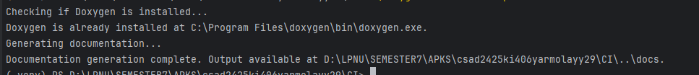

Рис.1 – Виконання СІ скрипту

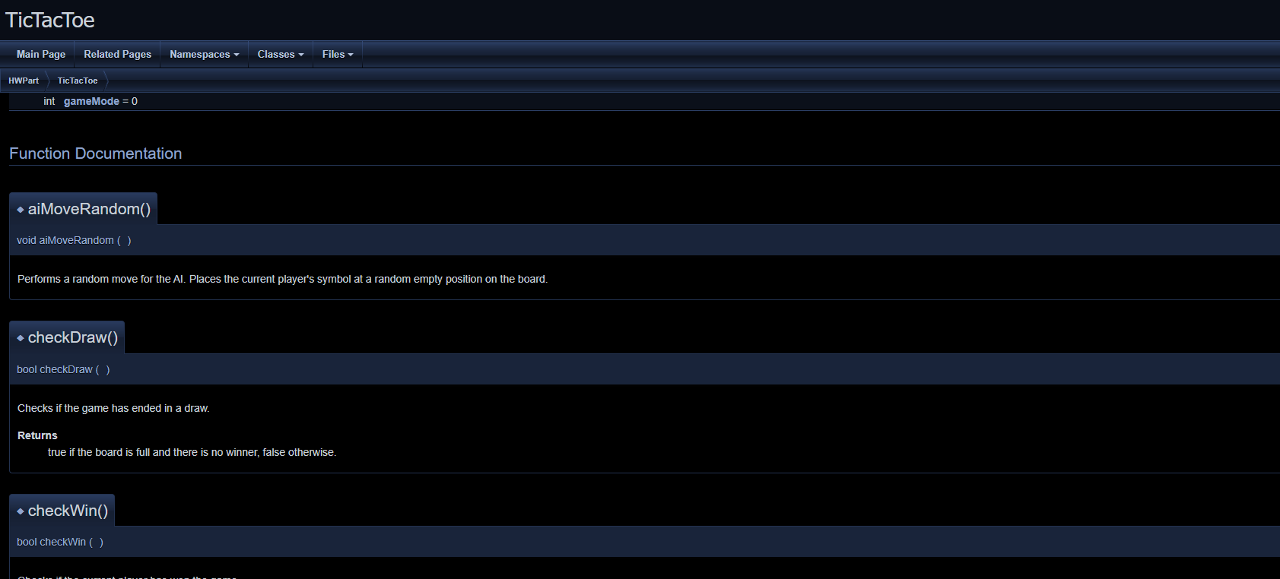

Рис.2 – Вигляд документації

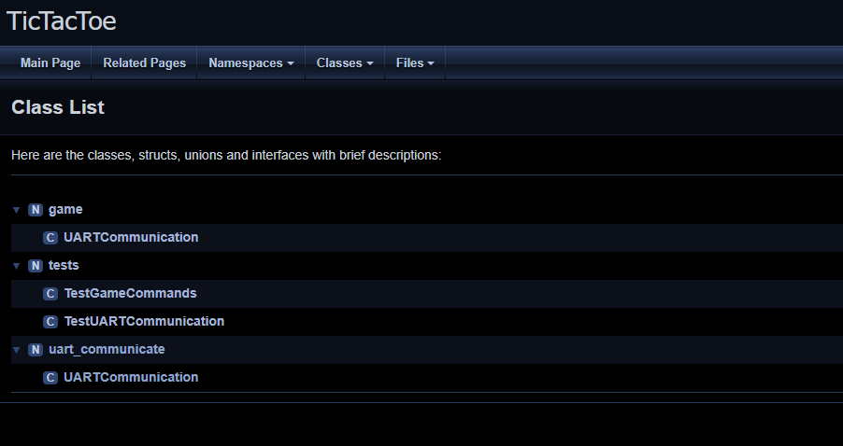

Рис.3 – Вигляд списку класів в документації

**Висновки**

На лабораторній роботі я додав документацію до проекту, додавши коментарі та згенерував Doxygen файл. Зробив скрипт для автоматизації встановлення Doxygen та генерації документації.

**Посилання**

1. <https://www.arduino.cc/>

2. https://uk.wikipedia.org/wiki/Doxygen

3. <https://docs.python.org/uk/3/library/tkinter.html>

4. <https://pyserial.readthedocs.io/en/latest/pyserial.html>

5. https://stackoverflow.com/questions/58622/how-to-document-python-code-using-doxygen